Exploring Operational Improvements to Long-Term Weather Forecasting Using Teleconnection Pattern Analysis

Everstream Analytics
MET 431/531
Spring Semester 2026

Exploring Operational Improvements to Long-Term Weather Forecasting Using Teleconnection Pattern Analysis

Project Team: |  | Tyson Stewart  Landon Moeller  Matthew Woods  Owen Cutinello
Project Advisor: |  | Dr. Haberlie
Company Sponsor: |  | Everstream Analytics.  San Marcos, California
Company Advisors: |  | Logan Bundy

MET 431/531
Spring Semester 2026

Department of Earth, Atmosphere, and Environment
Northern Illinois University
DeKalb, IL 60115

1. Introduction 4
a. Role of Everstream Analytics 4
b. Problem Statement 4
c. Introduction to Teleconnections 5
2. Proposed Approach 8
a. Regions of Study 8
b. Data 9
c. Correlation Analysis 10
d. Model Design 10
3. Preliminary Results 12
a. United States 12
b. South America 14
c. Europe 16
d. Asia 20
e. Australia 21
f. Intra-annual Variability 22
4. Future Work 24
a. Model Refinement and End Products 24
b. An ML Approach 25
5. Expected Results 25
6. References 26
Appendix A – Additional Tables 27

1. Introduction

a. Role of Everstream Analytics
Everstream Analytics is an analytics company that provides insights, forecasts, and assessments to maximize efficiency and profitability for their partners. Everstream provides services for a variety of private sector industries including the agriculture and energy sectors (Everstream Analytics 2026). These sectors are particularly vulnerable to long-term changes to weather, such as temperature and precipitation. Therefore, Everstream needs a reliable means to forecast potential weather conditions beyond 2-3 weeks. To assist in this operational need, it has been requested that the potential to utilize teleconnection data in addition to numerical weather modeling and Everstream’s internal products be investigated. This report, and the information that follows, is a preliminary summary of the problem at hand, a proposed solution, and initial results to said solution.

b. Problem Statement
Long-term forecasting is an essential part of operations for a variety of industry sectors and companies. Supply chain operations and economics often hinge on decisions and events that happen months in advance. An example of this can be seen with the grounding of the container ship Ever Given in March of 2021. The ship, travelling through the Suez Canal, ran aground in the southernmost stretch of the Canal, completely blocking sea travel along the Suez for six days (Gerson 2023). This grounding not just affected shipments on the ship itself, but also the backlog of hundreds of ships waiting to travel through the canal, and the ships that needed to reroute along longer routes to avoid the blockage. Overall, the economic impacts expanded far beyond the millions of dollars' worth of goods on the ship itself (Gerson 2023).
The incident involving the Ever Given container ship highlights both the interconnected nature of the supply chain as well as how singular events can ripple into much larger consequences spanning long beyond the initial timeframe. The same applies to meteorological events and as such, it is of great importance to companies and industries that accurate and reliable long-term forecasts of weather and climate are available. Such forecasts are critical in allowing companies and industries to prepare resources ahead of time to mitigate losses. However, this need for long-term forecasts often runs into conflict with the short-term nature of computational weather modeling. Many popular numerical weather models (GFS, HRRR, NAM, etc.) are designed to operate in one-to-ten-day intervals. Longer term numerical models do exist (such as CanSIPS, NMME, and ECMFW Monthly) but are limited in scope and use cases. As a result, it can be incredibly challenging to create actionable weather and climate forecasts for companies and industry and often involve a considerable amount of time and resources. There are, however, additional tools that can potentially be used to make this task easier, one of which being the analysis of “teleconnection” patterns.

c. Introduction to Teleconnections
Teleconnection patterns, broadly speaking, are climatological patterns that can create different regional effects downstream of the initial pattern. An example of such a pattern is the infamous “El Nino-Southern Oscillation” (ENSO) teleconnection. ENSO is primarily driven by long term changes to sea surface temperature in the Pacific that then in turn effects the predominant atmospheric pressure and weather patterns globally. As such, understanding what the current state of ENSO is can be critical to determining what long-term conditions in each region can be (Fig. 1).
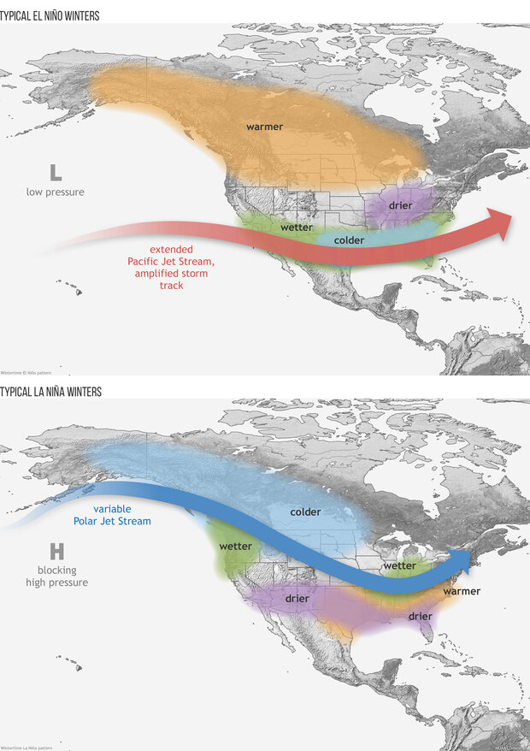
Figure 1: Map of North America with wintertime ENSO phase effects overlayed (referred to in the figure as El Nino and La Nina Winters). Figure from NOAA (2025).
Teleconnection Index Name | Abbreviation | Domain
El Nino-Southern Oscillation | ENSO 3.4 | Global
Multivariate ENSO Index | MEI | Global
Quasi-Biennial Oscillation | QBO | Global
Indian Ocean Dipole | IOD | Global
ENSO Modoki Index | EMI | Global
Interdecadal Pacific Oscillation | IPO | Global
Globally Averaged Angular Momentum | AAM-ANOM | Global
North Atlantic Oscillation | NAO | Northern Hemisphere
Arctic Oscillation | AO | Northern Hemisphere
Western Pacific Oscillation | WPO | Northern Hemisphere
Eastern Pacific Oscillation | EPO | Northern Hemisphere
Pacific North American Pattern | PNA | Northern Hemisphere
Pacific Decadal Oscillation | PDO | Northern Hemisphere
Atlantic Multidecadal Oscillation | AMO | Northern Hemisphere
Tropical North Atlantic Index | TNA | Northern Hemisphere
West Pacific Pattern | WP | Northern Hemisphere
East Atlantic Pattern | EA | Northern Hemisphere
Scandinavian Pattern | SCA | Northern Hemisphere
Polar/Eurasia Pattern | POL | Northern Hemisphere
East Atlantic/West Russia Pattern | EAWR | Northern Hemisphere
East Pacific/North Pacific Oscillation | EPNP | Northern Hemisphere
Northern Oscillation Index | NOI | Northern Hemisphere
Arctic Dipole Index | ADI | Northern Hemisphere
Southern Oscillation Index | SOI | Southern Hemisphere
Tropical Southern Atlantic Index | TSA | Southern Hemisphere
Antarctic Oscillation | AAO | Southern Hemisphere
Southern Atlantic Ocean Dipole | SAOD | Southern Hemisphere
Southern Pacific Ocean Dipole | SPOD | Southern Hemisphere
Trans-Polar Index | TPI | Southern Hemisphere

Table 1: Table of major teleconnection indices, their common abbreviations, and domain area. Note that this table is not meant to be all encompassing, as there are other indices not mentioned herein. Table created by authors from documentation provided by Everstream.
While ENSO is perhaps the most notorious example of teleconnections within popular culture, it is by no means the only pattern. A wide variety of teleconnections are present not just on a global scale, but also on a hemispheric level (Table 1). Each of these teleconnections has the potential to be a useful tool in long-term forecasting of future climatic conditions. Past research has highlighted the value of teleconnections for many use-cases including analyzing regional precipitation trends (González-Pérez et al. 2022; Goodrich and Walker 2011), agricultural risk forecasting (Zhang et al. 2021), and seasonal temperature forecasting (Rust et al. 2015). As such, the potential for teleconnection analysis to be used in an operational setting, especially as an aid for regional long-term forecasting, is an enticing prospect. Therefore, this research seeks to explore the creation of an operational model/framework for integrating teleconnection analyses into actionable climate forecasts.

2. Proposed Approach

a. Regions of Study
Everstream Analytics is interested in 13 regions across the globe, situated in North America, South America, Europe, Asia, and Australia (Fig. 2). The eight regions in the Northern Hemisphere are the Midwest U.S., Northeast U.S., Southern Plains U.S., Eastern Europe, Western Europe, the Black Sea Region, India, and East Asia. The five regions located in the Southern Hemisphere are Northern Brazil, Southern Brazil, Argentina, Eastern Australia, and Western Australia. Regions do not have specific longitude and latitude bounds but are broadly defined by the company advisor. Examining these areas for different prospects, whether for agriculture or for supply chain concerns, is important for the insights that Everstream hopes to provide to clients.
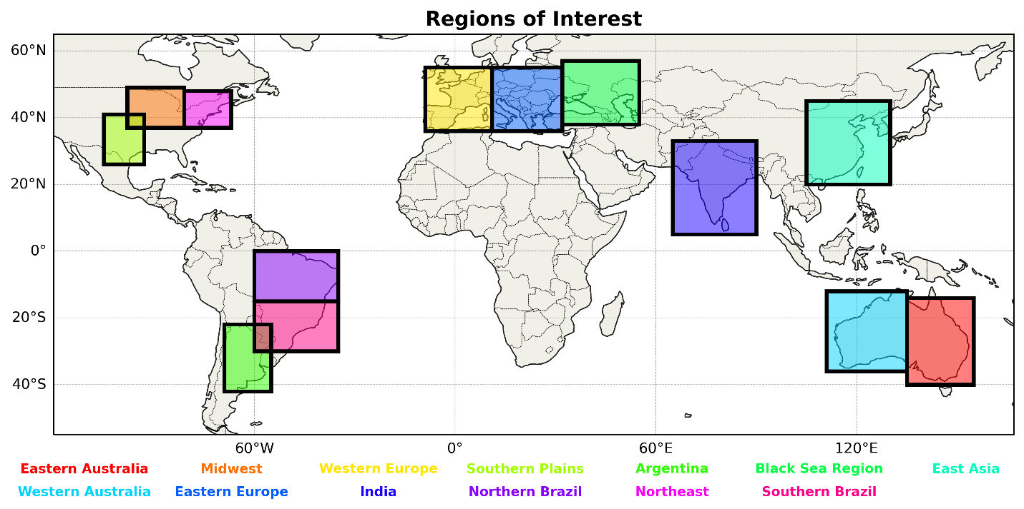
Figure 2. Thirteen regions of interest in North America, South America, Europe, Asia, and Australia.

b. Data
Two sets of monthly data from 1950 to 2024, for a total of 900 months, are used in this project. All data was downloaded in Comma-Separated Values (CSV) form as 42 individual files. Data for 29 teleconnection indices (16 with influence in the Northern Hemisphere, six in the Southern Hemisphere, and seven across the globe) was obtained from the National Oceanic and Atmospheric Administration (NOAA). Each month contains a mean index value for all teleconnections, where a positive (negative) value indicates a positive (negative) phase, except for ENSO3.4, which additionally contains a neutral phase between -0.5 and 0.5. Climate anomaly data was retrieved from European Centre for Medium-Range Weather Forecasts Reanalysis v5 (ERA5). The monthly value represents the spatial mean in each region. The variables downloaded were 2-meter air temperature (T2M) and total precipitation (TP). The baseline period of 1980-2010 was used to calculate temperature anomaly (T2M_Anom), precipitation anomaly (TP_Anom), standardized temperature anomaly (T2M_Std), and standardized precipitation anomaly (TP_Std).

c. Correlation Analysis
Monthly teleconnection index values were aligned with the corresponding ERA5 climate anomaly values from the CSV files into Network Common Data Form (netCDF) files for comparison by hemisphere. Pearson correlation (r) was calculated for each region using both global teleconnections and relevant hemisphere teleconnections with temperature and precipitation standardized anomaly data. In this study, correlation strengths are arbitrarily defined as weak (r < 0.30), moderate (0.30 $≤$r < 0.50), and strong (r $≥$ 0.50). Initial analysis was mostly conducted amongst all months, but there was some exploration of intra-annual variations. R-Squared ($R^{2}$) was also calculated for each instance to show the proportion of variance in a dependent variable explained by independent variables through a regression model. To perform a statistical analysis, the Pearson p-value was calculated for each. Correlations with a p-value less than 0.05 were deemed to be statistically significant, and a p-value less than 0.01 as very statistically significant. The Pearson r and p-values are used to determine which teleconnection indices may prove useful in the prediction of climate anomalies in a model. In each region, the top ten warmest and coldest (wettest and driest) months for temperature anomaly (precipitation anomaly) for each teleconnection index are also highlighted for further reference and investigation.

d. Model Design
To predict monthly climate anomalies in each region, a multiple linear regression (MLR) model framework will need to be developed to account for complimentary influences of several teleconnections. MLR analysis considers the input of several predictors to develop a relationship with and produce a prediction of a continuous response variable (Alexopoulos 2010). In the context of this project, the predictors are the teleconnection indices, and the response variable is the resulting T2M or TP anomaly. Because of the wide-ranging intra-annual variability that exists amongst teleconnection correlations with climate anomalies, a month-specific approach will be needed to manage such discrepancies. While this can be handled, it will be difficult to incorporate lag time, which differs significantly across teleconnections. Building this model will require separating observed correlations by month and building 12 different versions per variable with 75 data points each month.
Similar to the correlation analysis explained in the previous section, this MLR model will take monthly teleconnection values and T2M_Std and TP_Std data for each region. This time, all teleconnections will be considered together as predictors of the monthly climate anomaly. The model will likely be built using the statsmodels package in Python to fit with ordinary least squares (OLS). The output of this model should be a predicted anomaly value for T2M and TP for each month in each region, which can be categorized as either above normal, average, or below normal.

3. Preliminary Results

a. United States
The three regions of focus within the United States are the Midwest, the southern Great Plains, and the Northeast. Starting with the Midwest using Northern Hemisphere temperature teleconnection data, the East Pacific North Pacific (EPNP) pattern has the strongest correlation with a Pearson value of –0.4295. Along with a p-value of < 0.01, this marks it as being very statistically significant. The East Pacific Oscillation (EPO) and Arctic Oscillation (AO) come next, both being very statistically significant. Following these are the Western Pacific Oscillation (WPO) and the Atlantic Multidecadal Oscillation (AMO). Regarding the most significant global teleconnections, the El Nino Modoki Index (EMI) is the most statistically significant and has a Pearson value of –0.1460.
The Southern Plains’ most significant teleconnection correlation with temperature is the EPNP with a Pearson value of –0.2673. Following that, the AO, the Pacific Decadal Oscillation (PDO), the Eastern Pacific Oscillation (EPO), and AMO among the most significant teleconnections. The global teleconnection that holds the most significance for the Southern Plains is the Interdecadal Pacific Oscillation (IPO).
In the Northeast U.S., the topmost teleconnection regarding temperature anomalies is the EPNP with a Pearson value of –0.3512. This teleconnection’s correlation for this region is very statistically significant. The AMO is next being very statistically significant. Next, the most significant teleconnections are the EPO, the AO, and last, the North Atlantic Oscillation (NAO). The top global teleconnection for the Northeast is the EMI with a Pearson value of –0.1754. Overall, the commonality in the United States is that teleconnections in the East Pacific, such as EPNP and EPO, have the strongest correlations with temperature departures (Fig. 3).
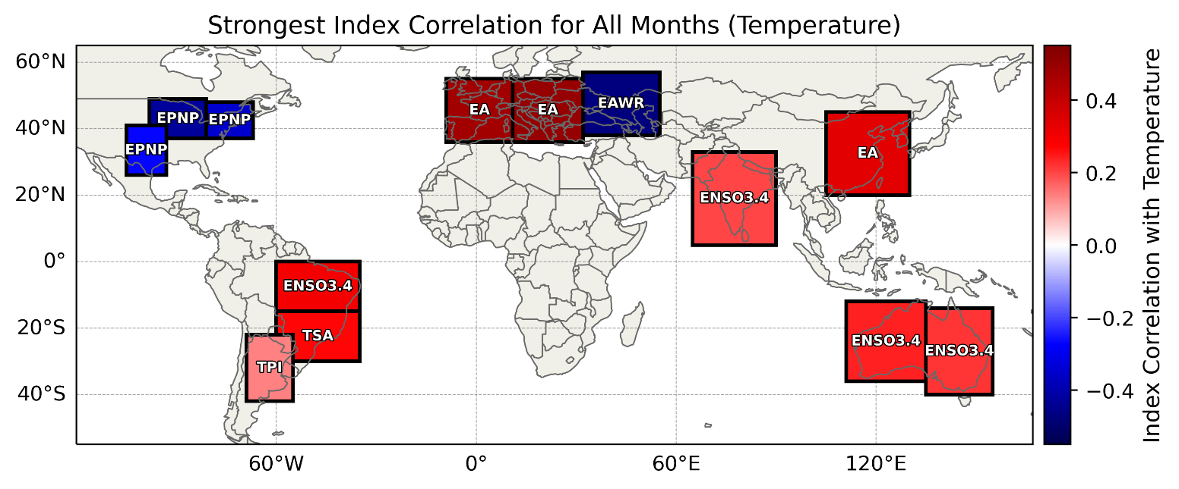
When examining precipitation across all months from 1950-2024, and using Northern Hemisphere teleconnections, the Midwest is most influenced by the Pacific-North American Pattern (PNA) with a Pearson value of –0.1920 and is very statistically significant. PNA is followed by the Scandinavian Pattern (SCA) and the Atlantic Multidecadal Oscillation (AMO), which are both very statistically significant. The East Pacific/North Pacific Oscillation (EPNP) and the Pacific Decadal Oscillation (PDO) are both statistically significant. Out of the global teleconnections, the Midwest is most influenced by the Multivariate ENSO Index (MEI) with a Pearson value of 0.0999 and is very statistically significant. In addition to the top five most influential teleconnections, the Midwest is also statistically significantly influenced by the AO, the Tropical Northern Atlantic Index (TNA), and the East Atlantic/West Russia Pattern (EAWR).
Figure 3. The strongest index by Pearson correlation across all months for T2M_Std by region.
The Southern Plains is most influenced by the PDO with a Pearson value of 0.1870 and is very statistically significant. Following the PDO are the AMO and EAWR, which are both very statistically significant. Then there is the PNA and the Northern Oscillation Index (NOI), which are both statistically significant. The most impactful global teleconnection is the MEI with a Pearson value of 0.1984 and is very statistically significant.
In the Northeast, EPNP is the most influential teleconnection with a Pearson value of 0.0636. Following EPNP, the SCA, the Northern Atlantic Oscillation (NAO), the PNA, and the Eastern Pacific Oscillation (EPO) complete the top five influential teleconnections. The most influential global teleconnection is the Indian Ocean Dipole (IOD) with a Pearson value of 0.0368.

b. South America
Concerning South America, the main regions of focus are Northern Brazil, Southern Brazil, and Argentina. Starting with Northern Brazil, the top temperature teleconnection is the Tropical Southern Atlantic Index (TSA) with a Pearson value of 0.2470. Following the TSA teleconnection is the Southern Oscillation Index (SOI), the Antarctic Oscillation (AAO), the Southern Atlantic Ocean Dipole (SAOD), and the Trans Polar Index (TPI). The most significant Global temperature teleconnection is the El Nino Southern Oscillation (ENSO 34) for Northern Brazil with a Pearson value of 0.2975.
In Southern Brazil, the topmost significant temperature teleconnection is the TSA with a Pearson value of 0.2680. Following the TSA is the TPI, the SOI, the AAO, and the SAOD. These teleconnections show relatively lower correlations, and none are considered very statistically significant. Concerning Southern Brazil, the top global teleconnection is the ENSO 34 with a Pearson value of 0.2365.
In Argentina, the temperature teleconnection with the highest statistical significance is the TPI with a Pearson value of 0.1355. The SOI, SPOD, AAO, and the TSA teleconnections all follow the TPI, all being statistically significant. Regarding the top global temperature teleconnection, the IPO is the most statistically significant with a Pearson value of –0.0442. The IPO teleconnection for Argentina has a much weaker correlation strength in comparison to other teleconnections.
When examining precipitation in South America using southern hemisphere teleconnections, Northern Brazil is most impacted by the Southern Pacific Ocean Dipole (SPOD) with a Pearson value of 0.0610. After SPOD, SAOD, TPI, TSA, and SOI have the most impact on the precipitation in the region. The most impactful global teleconnection is AAM with a Pearson value of 0.1151 and is very statistically significant.
Southern Brazil is most impacted by SPOD with a Pearson value of 0.2461 and is very statistically significant (Fig. 4). Following SPOD are TPI and AAO which are very statistically significant, and SAOD and TSA are statistically significant. IPO is the most influential global teleconnection with a Pearson value of 0.2291 and is very statistically significant.
In Argentina, SPOD is the most impactful teleconnection with a Pearson value of 0.2116 with SOI not far behind. Both are very statistically significant. After SPOD and SOI, AAO, SAOD, and TSA are the next three most influential teleconnections in the region. The most influential global teleconnection is IPO with a Pearson value of 0.2207 and is very statistically significant.

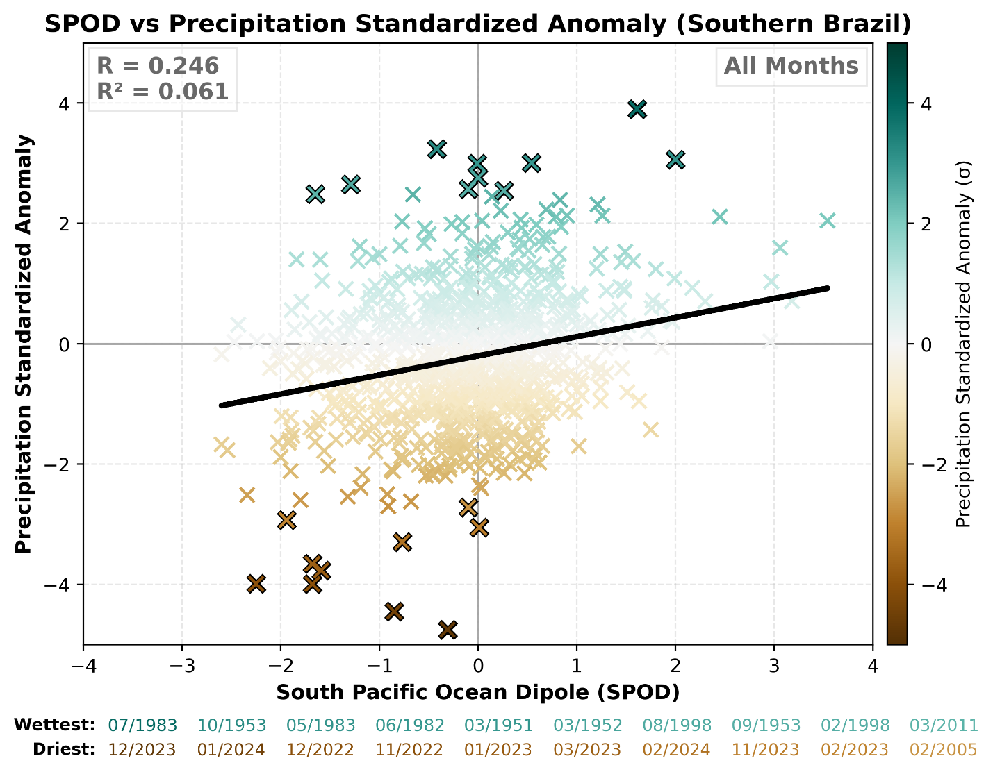
c. Europe
Figure 4. Correlation of the SPOD with TP_Std across all months in Southern Brazil. The black line denotes the line of best fit. Pearson r and $R^{2}$ values are printed in the top left.
The main regions of focus within Europe are Western Europe, Eastern Europe, and the Black Sea. Starting with western Europe regarding temperature anomalies, the most statistically significant temperature teleconnection is the EA with a Pearson value of 0.4725. This teleconnection is very statistically significant for Western Europe. The AO and the AMO teleconnections are also very statistically significant. Following these teleconnections are the NAO and AO for Western Europe. The dominant global teleconnection for Western Europe is ENSO3.4 with a Pearson value of 0.1268. ENSO3.4 is statistically significant in Western Europe.
For Eastern Europe, the dominant temperature anomaly teleconnection is the EA with a Pearson value of 0.5020. This teleconnection for Eastern Europe has a strong correlation strength and has high statistical significance. The AMO and the AO are very statistically significant. Eastern Europe is also influenced by the NAO and the EAWR regarding temperature anomalies, both showing lower but still relevant statistical significance. The dominant global teleconnection for Eastern Europe is the ENSO 34 with a Pearson value of 0.1056. This global teleconnection concerning temperature anomalies is statistically significant.
Regarding the Black Sea Region for temperature anomalies, the EAWR is the most statistically significant with a Pearson value of –0.4722. The EAWR has moderate correlation strength, indicating that it is very statistically significant. Following the EAWR is the AMO, which is also very statistically significant with a Pearson value of 0.3031. The SCA, EA, and the TNA teleconnections all are statistically significant, but show weaker correlation strength. The top global teleconnection concerning temperature anomalies is the EMI with a Pearson value of -0.0892 being statistically significant.
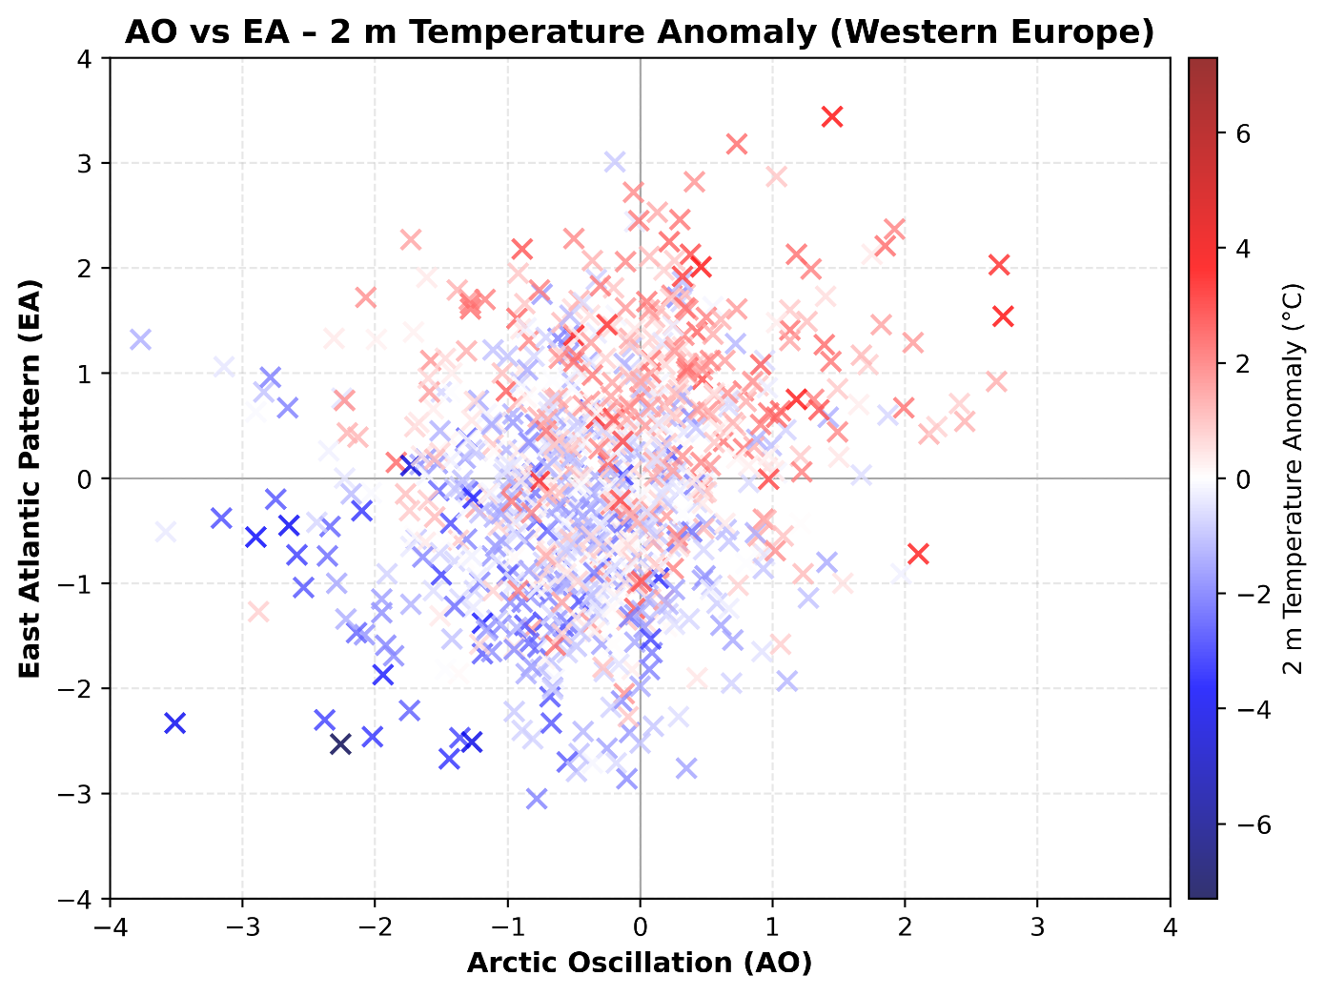
The dominant teleconnection within the Northern Hemisphere correlated to precipitation in Western Europe is the Arctic Oscillation (AO) with a Pearson value of –0.3059, a moderate correlation strength, and is statistically significant. After the AO, the SCA, NAO, the Eastern Atlantic Pattern (EA), and EAWR complete the top five most influential teleconnections for Western Europe and are very statistically significant. The most impactful global teleconnection is the Interdecadal Pacific Oscillation (IPO) with a Pearson value of 0.1281 and is very statistically significant. In addition to the top five most impactful teleconnections, Western Europe is influenced by the EPNP, PDO, Arctic Dipole Index (ADI), NOI, and AMO, which are all very statistically significant, and EPO, West Pacific Patter (WP), and the WPO, which are all statistically significant. When combining two teleconnections with at least moderately strong correlation in a region, additional conclusions can be made. For example, examining both the AO and EA in Western Europe shows that when both are negative (positive), below (above) average temperatures are favored in the region (Fig. 5).
Figure 5. AO and EA with 2 m temperature anomaly in Western Europe across all months.
Eastern Europe is most influenced by the AO with a Pearson value of –0.3752 and the EAWR, which both have a moderate correlation strength and are very statistically significant. Following those two, Eastern Europe is impacted by the EA, NAO, and PDO, which are all statistically significant. The most influential global teleconnection that impacts Eastern Europe is the IPO with a Pearson value of 0.0498 and is very statistically significant. In addition to the top five teleconnections, Eastern Europe is influenced by ADI, SCA, the Polar/Eurasia Pattern (POL) which are all very statistically significant, and the AMO, WPO, and EPO which are all statistically significant.
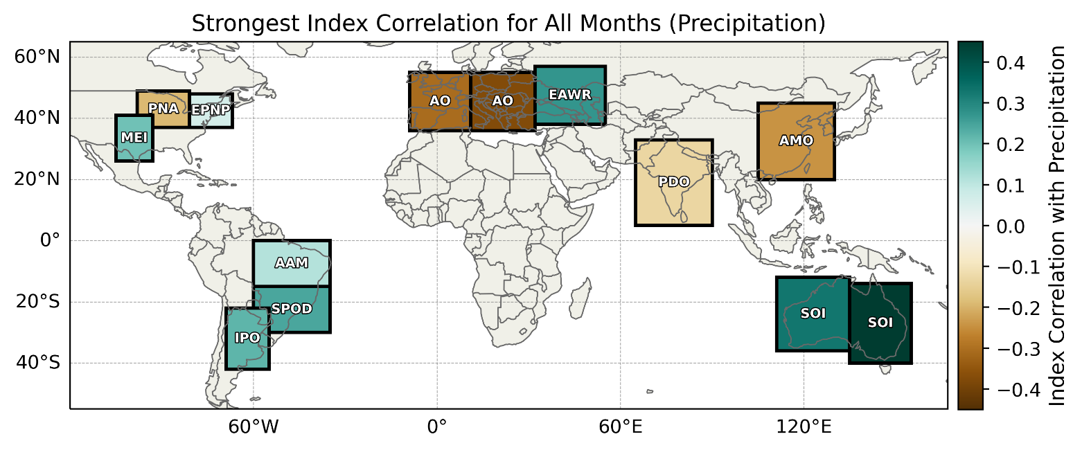
Within the Black Sea Region, EAWR is the most impactful teleconnection with a Pearson value of 0.2732 and is very statistically significant. Following this, the EAWR, PDO, AMO, EA, and SCA are the most influential and are all very statistically significant. On the global scale, the Globally Averaged Atmospheric Angular Momentum index (AAM) is the most impactful with a Pearson value of 0.1918 and is very statistically significant. Along with the top five, other impactful teleconnections are POL and AO, which are both very statistically significant and NOI, which is statistically significant. Of interesting note, in Western Europe and Eastern Europe, the strongest correlation (AO) is negative while the strongest correlation in the Black Sea Region (EAWR) is positive (Fig. 6).
Figure 6. The strongest index by Pearson correlation across all months for TP_Std by region.

d. Asia
The regions of focus are India and East Asia. Starting off with India, the top teleconnection regarding temperature anomalies is the PDO with a Pearson value of 0.1790. Following the PDO are the TNA, WPO, ADI, and WP teleconnections. All these teleconnections show statistical significance. The most dominant global teleconnection for India is the ENSO 34 with a Pearson value of 0.1982 and holds statistical significance.
Regarding temperature anomaly teleconnections for East Asia, the top teleconnection for this region is the EA with a Pearson value of 0.3384. The EA teleconnection has a moderate correlation strength and is very statistically significant. The next relevant teleconnection for East Asia regarding temperature anomalies is the AMO with a Pearson value of 0.3235. This teleconnection also has moderate correlation strength and is therefore very statistically significant. The next three teleconnections for India are the AO, TNA, and the PDO, all holding statistical significance. The most influential global teleconnection for East Asia regarding temperature anomalies is the EMI with a Pearson value of –0.1230.
In India, the most influential teleconnection is PDO with a Pearson value of –0.1318 and is very statistically significant. Following the PDO are the NOI, AMO, and AO which are all statistically very significant. The fifth and final most influential teleconnection is EPO. The most influential global teleconnection is MEI with a Pearson value of –0.1268 and is very statistically significant.
East Asia is most impacted by the AMO with a Pearson value of –0.2452 and is very statistically significant. After AMO, TNA, NAO, and PDO have the most influence and are very statistically significant. The next most impactful is the SCA and ADI, which are both statistically significant. The most influential global teleconnection is MEI with a Pearson value of 0.1321 and is very statistically significant.

e. Australia
Australia is divided into two regions, Eastern and Western Australia. Starting with western Australia concerning temperature anomalies, the dominant teleconnection is the SOI with a Pearson number of –0.1981. The next top teleconnections for western Australia are the AAO, TSA, SAOD, and the SPOD. All these teleconnections show statistical significance but are not highly statistically significant. The dominant global teleconnection for western Australia is the ENSO 34 with a Pearson number of 0.2375 being statistically significant.
Eastern Australia’s top teleconnection concerning temperature anomalies is the TSA with a Pearson value of 0.1525. The next most influential teleconnections for Eastern Australia are the SOI, AAO, TPI, and the SAOD, all being statistically significant. The dominant global teleconnection for this region is the ENSO 34 with a Pearson number of 0.2192.
Eastern Australia is most influenced by SOI with a Pearson value of 0.4485 and AAO which are both very statistically significant. Then there is SPOD which is statistically significant, TSA and TPI. Eastern Australia is most influenced by the ENSO global teleconnection with a Pearson value of –0.2743 and is very statistically significant.
Western Australia is most influenced by the SOI with a Pearson value of 0.3276 and is very statistically significant. After SOI is AAO which is very statistically significant, SPOD, TPI, and TSA. The most influential global teleconnection is ENSO with a Pearson value of –0.2126 and is very statistically significant.

f. Intra-annual Variability
Looking at Figure 7, there is a clear image that ENSO is more impactful in the Southern Hemisphere than it is in the Northern Hemisphere. Most of the Northern Hemisphere has a correlation variation between 0.17 and 0.3, while the Southern Hemisphere has a correlation variation anywhere from 0.35 to 0.55. The two notable regions in the northern hemisphere that have seen higher correlation variation are Eastern Europe and India. Argentina has the lowest correlation variation concerning ENSO sitting at 0.243. The months of November, March, and December tend to see the strongest correlation variation in the majority of the Southern Hemisphere regions.
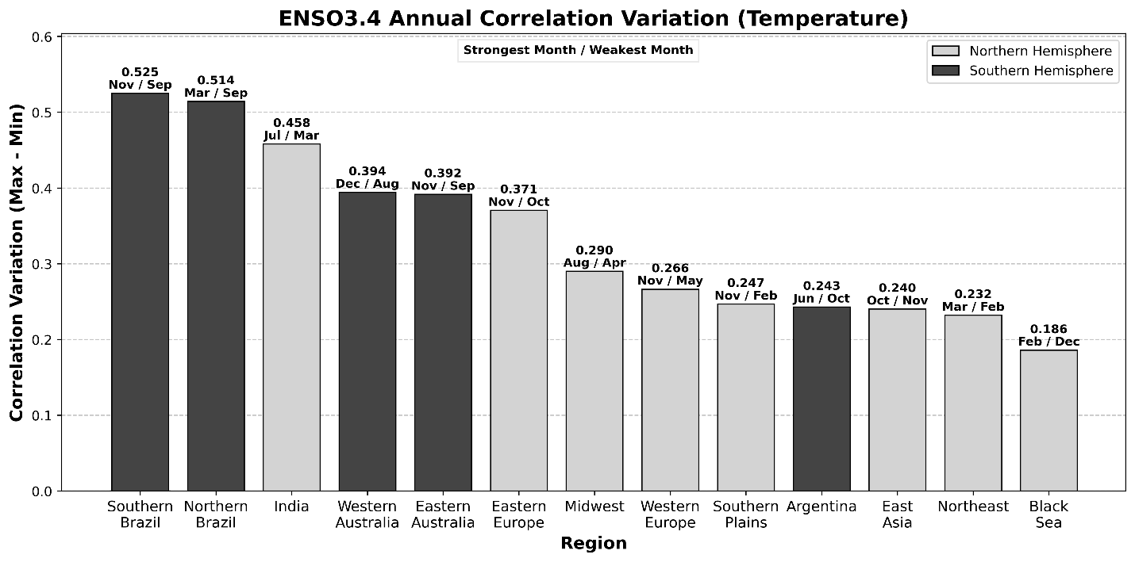
Figure 7. Intra-annual variation (maximum – minimum) in Pearson r correlation strength for 2 m temperature and ENSO 3.4 by region. Southern Hemisphere regions are represented by the dark gray bars while Northern Hemisphere regions are in the light gray bars. The Pearson r value, the month with the strongest correlation and the month with the weakest correlation are printed above each region.
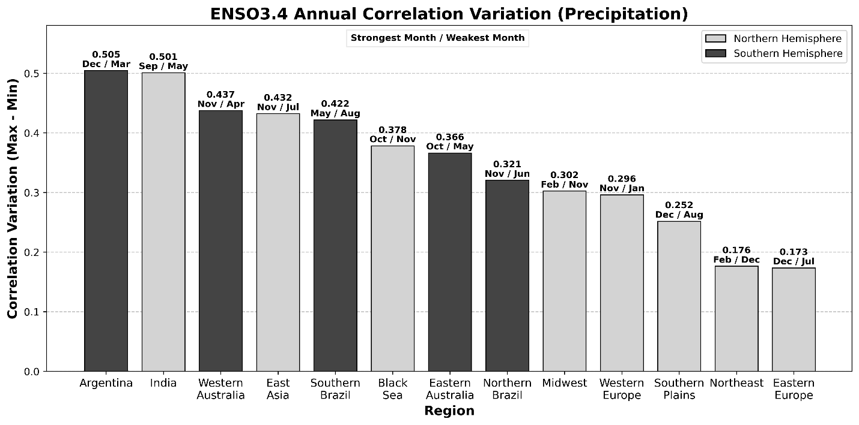
Due to seasonal changes and shifts in weather patterns, strength and direct correlation between regions and their respective indices will fluctuate and will have different indices taking the title of most influential. Precipitation is impacted by the correlation between ENSO 3.4 and the specific regions, and how it can be very influential to one region and have little impact on other regions during the same month (Fig. 8). The Southern Plains and the Northeast are good examples of this. During the month of December, ENSO has its biggest impact on precipitation for the Southern Plains, while the Northeast is the least impacted by ENSO as it will be all year.
Figure 8. Same as in Figure 7, but for precipitation.

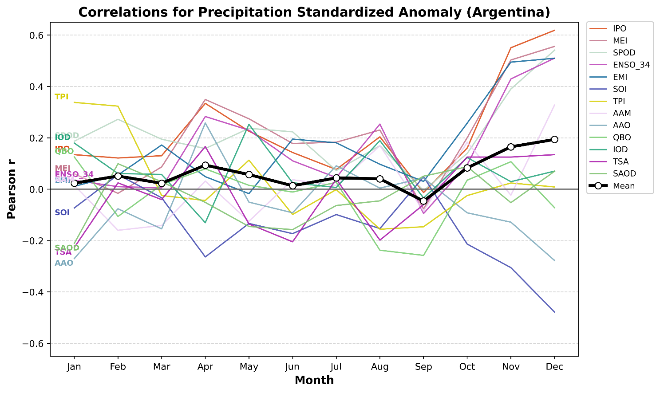
To examine an example of intra-annual variability, each Southern Hemisphere and global teleconnection’s correlation with precipitation in Argentina is plotted throughout the year (Fig. 9). It is easy to see a teleconnection such as TPI have a high correlation in January but have a low correlation throughout the rest of the year. Many indices such as the IPO, which remains around a Pearson r value of 0.2 - 0.4 throughout the year, has a large jump exceeding a 0.6 correlation value as it gets closer to the end of the year. The main takeaway is that correlation strengths both increase and diverge towards summer in Argentina. A similar analysis can be done for each region to show varying intra-annual trends.
Figure 9. Correlation between precipitation standardized anomaly and the six Southern Hemisphere teleconnections and the seven global teleconnections plotted by month in Argentina. The mean of all 13 teleconnections is plotted in thick black.

4. Future Work

a. Model Refinement and End Products
We will build on the multiple linear regression model framework described in section 2d by applying weights to the input data by region based on our correlation analysis and then apply the model. Before we run the model with sample data, we will construct several output products that will be designed to be helpful to Everstream Analytics. An idealized basic product from the regression model would be an identified category of above average, average, or below average temperatures or rainfall that is expected for next month in each region, along with tercile probabilities to express uncertainty. This can be displayed both in map format and in table format. We also hope to support the output with the Pearson r value of the teleconnections with the strongest correlations listed to the side. Additionally, top 10 analog months provided alongside each prediction can be useful for further investigation by Everstream to offer more context based on past occurrences. Finally, it could be valuable to create a “proxy year” product that attempts to find a historical year that best matches forecasted index values.

b. An ML Approach
The complicated relationships given by regional and intra-annual variability present challenges for a simple statistical model. These nuances in the application of teleconnections and climate anomaly forecasts may be better handled by a machine-learning model (Helali et al. 2023). An ML approach could be explored to address the limitations of the current MLR model and potentially increase predictive skill through the learning of specific patterns. Even if this is not touched during this semester, our current model can provide a well-developed framework and dataset to build off for an ML model.

5. Expected Results
We expect the month-specific MLR models will output representative climate anomaly predictions that align well with the relationships that were already analyzed. In other words, we should see predictions that fall near the sign and magnitude of the known correlations. It is anticipated that the model will properly capture the teleconnections in the relevant hemisphere of each region, as well as the global teleconnections. We do also predict that there may be some lack of skill in terms of the intra-annual variability, but that this will be better handled than a single linear regression model.

6. References
Everstream Analytics, 2026: Everstream Analytics. https://www.everstream.ai/.
Gerson, A., 2023: Stranding of the Mega-Ship Ever Given in the Suez Canal: Causes, Consequences, and Lessons to Be Learned. The Suez Canal: Past Lessons and Future Challenges, C. Lutmar and Z. Rubinovitz, Eds, Palgrave Studies in Maritime Politics and Security, Springer International Publishing, 231–252, https://doi.org/10.1007/978-3-031-15670-0_12.
González-Pérez, A., R. Álvarez-Esteban, A. Penas, and S. Del Río, 2022: Analysis of recent rainfall trends and links to teleconnection patterns in California (U.S.). Journal of Hydrology, 612, 128211, https://doi.org/10.1016/j.jhydrol.2022.128211.
Goodrich, G. B., and J. M. Walker, 2011: The Influence of the PDO on Winter Precipitation During High- and Low-Index ENSO Conditions in the Eastern United States. Physical Geography, 32, 295–312, https://doi.org/10.2747/0272-3646.32.4.295.
Helali, J., M. Nouri, M. Mohammadi Ghaleni, S. A. Hosseni, F. Safarpour, A. Shirdeli, P. Paymard, and Z. Kalantari, 2023: Forecasting precipitation based on teleconnections using machine learning approaches across different precipitation regimes. Environ Earth Sci, 82, 495, https://doi.org/10.1007/s12665-023-11191-9.
NOAA, 2025: El Niño & La Niña (El Niño-Southern Oscillation). Climate.gov, https://www.climate.gov/enso.
Rust, H. W., A. Richling, P. Bissolli, and U. Ulbrich, 2015: Linking teleconnection patterns to European temperature – a multiple linear regression model. metz, 24, 411–423, https://doi.org/10.1127/metz/2015/0642.
Zhang, N., T. B. Pathak, L. E. Parker, and S. M. Ostoja, 2021: Impacts of large-scale teleconnection indices on chill accumulation for specialty crops in California. Science of The Total Environment, 791, 148025, https://doi.org/10.1016/j.scitotenv.2021.148025.

Appendix A – Additional Tables
Region | Relevant Hemisphere | Global
Eastern EU | EA: 0.5020 | ENSO3.4: 0.1056
Western EU | EA: 0.4725 | ENSO3.4: 0.1268
Black Sea Region | EAWR: -0.4722 | EMI: -0.0892
Midwest US | EPNP: -0.4295 | EMI: -0.1460
Northeast US | EPNP: -0.3512 | EMI: -0.1754
East Asia | EA: 0.3384 | EMI: -0.1230
Southern Brazil | TSA: 0.2680 | ENSO3.4: 0.2365
Southern Plains US | EPNP: -0.2673 | IPO: -0.1857
Northern Brazil | TSA: 0.2470 | ENSO3.4: 0.2975
Western AU | SOI: -0.1981 | ENSO3.4: 0.2375
India | PDO: 0.1790 | ENSO3.4: 0.1982
Eastern AU | TSA: 0.1525 | ENSO3.4: 0.2192
Argentina | TPI: 0.1355 | IPO: -0.0442
Table A1. Strongest relevant hemisphere and global teleconnection by region by Pearson r for T2M_Std across all months.
Region | Relevant Hemisphere | Global
Eastern AU | SOI: 0.4485 | ENSO: -0.2743
Eastern EU | AO: -0.3752 | IPO: 0.0498
Western AU | SOI: 0.3276 | ENSO: -0.2126
Western EU | AO: -0.3059 | IPO: 0.1281
Black Sea Region | EAWR: 0.2732 | AAM: 0.1918
Southern Brazil | SPOD: 0.2461 | IPO: 0.2291
East Asia | AMO: -0.2452 | MEI: 0.1321
Argentina | SPOD: 0.2116 | IPO: 0.2207
Midwest US | PNA: -0.1920 | MEI: 0.0999
Southern Plains US | PDO: 0.1870 | MEI: 0.1984
India | PDO: -0.1318 | MEI: -0.1268
Northeast US | EPNP: 0.0636 | IOD: 0.0368
Northern Brazil | SPOD: 0.0610 | AAM: 0.1151
Table A2. As in Table 3, but for TP_Std.

